MODELLING QUANTUM FOURIER ADDERS, QUANTUM FOURIER TRANSFORM ADDERS, AND APPROXIMATE QUANTUM FOURIER TRANSFORM ADDERS

Shehwar F. Finger

School of Electrical & Information Engineering, University of the Witwatersrand, Private Bag 3, 2050, Johannesburg, South Africa

# Introduction

Quantum computing has gained tremendous attention due to its potential for solving complex problems exponentially faster than classical computing. In quantum computing, addition operations are performed through quantum circuits, which employ quantum gates to manipulate quantum states. This report aims to model two types of quantum adders, Quantum Fourier Adders (QFTA) and Quantum Fourier Transform Adders (QFTA) and Approximate Quantum Fourier Transform Adders (QFTA). The report also discusses the use of controlled-phase gates and Hadamard gates in quantum circuits and their matrix representations.

# Method

## Background

## In classical computing, addition operations are carried out through a logical gate known as the half-adder. It is important to note that these calculations are performed on binary numbers. The half-adder employs two fundamental concepts, namely the Sum and the Carry, to add two numbers without carrying additional binary digits. The Sum adds the numbers together, while the Carry carries the additional binary digit to be added to the next value.

## Similarly, in quantum computing, half-adders can be designed to facilitate addition operations. The design of the quantum circuit entails utilizing a Sum and Carry circuit. Alternatively, Quantum Fourier Transform Adders (QFTA) provide an alternate means to perform addition operations in quantum computing. These adders utilize Quantum Fourier Transform (QFA) to execute operations. The QFA, instead of adding the numbers themselves (moving the state from |0> to |1> or vice versa), employs rotations in the Z-axis to provide a more stable approach to store and add numbers. The QFTA employs Hadamard gates and Controlled-Phase gates in its addition operations. This combination of gates is utilized in two combinations of the Quantum Fourier Transform (QFT) and the Inverse Quantum Fourier Transform (IQFT), along with an adder composed solely of Controlled-Phase gates.

## Logic Gates

To model the two different types of adders we will be making use of Hadamard gates and controlled-phase gates. Hence it is important to look at the matrix representation of both types of gates:

The identity matrix can be represented as:

$$\left[\begin{matrix}1 & 0 \\ 0 & 1\end{matrix}\right]$$

The Hadamard gate can be represented as:

$$\frac{1}{\sqrt{2}}\left[\begin{matrix}1 & 1 \\ 1 & -1\end{matrix}\right]$$

The Control Not (CNOT) gate can be represented as:

$$\left[\begin{aligned}\begin{matrix}1 & 0\end{matrix} \begin{matrix}0 & 0\end{matrix} \\ \begin{matrix}0 & 1\end{matrix} \begin{matrix}0 & 0\end{matrix} \\ \begin{matrix}0 & 0\end{matrix} \begin{matrix}0 & 1\end{matrix} \\ \begin{matrix}0 & 0\end{matrix} \begin{matrix}1 & 0\end{matrix}\end{aligned}\right]$$

The controlled-phase gate can be represented as:

$$\left[\begin{aligned}\begin{matrix}1 & 0 & 0 \\ 0 & 1 & 0 \\ 0 & 0 & 1\end{matrix} \begin{matrix}0 \\ 0 \\ 0\end{matrix} \\ \begin{matrix}0 & 0\end{matrix} \begin{matrix}0 & e^{-iϑ}\end{matrix}\end{aligned}\right]$$

Where the $ϑ$ represents the phase shift. The controlled-phase gate acts on two qubits where the first qubit is the control and the second is the target. If the control qubit is in the state |1> then the target undergoes a phase shift of $ϑ.$ However, if it is in state |0> then the qubit remains unchanged.

The truth table for this gate looks as follows:

Table 1:Truth table for the Controlled-Phase gate

|  |  |  |
| --- | --- | --- |
| Control Qubit | Target Qubit | Output |
| |0> | |0> | |0> |
| |0> | |1> | |1> |
| |1> | |0> | |0> |
| |1> | |1> | |1>eiϑ |

## Half-adders in Quantum Computing

The Approximate Quantum Fourier Transform Adder (AQFTA) operates akin to the QFTA circuit, albeit with a reduced count of gates. The employed controlled-phase gates in the QFTA are abridged and estimated, with the approximation varying based on the specific application.

## Sum, Carry and Inverse Carry quantum circuits.

Figure 1: Carry Gate.

Figure 2:Sum Gate.

## Quantum Fourier Transform Circuit

The QFT circuit uses Hadamard gates and Controlled-Phase gates. An example of a 3-qubit QFT circuit can be found in figure 3.

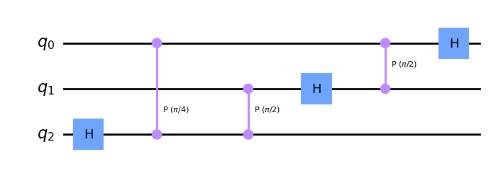

Figure 3:Quantum Fourier Transform circuit.

## Approximate Quantum Fourier transform adder.

The Approximate Quantum Fourier transform adder (AQFTA) functions in a similar manner to the QFTA circuit, albeit with a lower number of gates. The controlled-phase gates employed in the QFTA are diminished and approximated, with the approximation varying depending on the application.A picture containing line, diagram, screenshot, plot

Figure 4: Approximate Quantum Fourier Transform circuit.

## Unitary Matrix of 1, 2, 3 wire QFT circuits.

The calculation of Unitary Matrices of 1, 2, 3 wire QFT circuits makes use of Hadamard gate, Identity, Controlled-Phase gate matrices.

### Unitary Matrix of a 1-wire QFT circuit

The 1-wire QFT circuit is just the Hadamard gate and hence its Unitary Matrix is that of the Hadamard gate shown earlier.

### Unitary Matrix of a 2-wire QFT circuit

The 2-wire QFT circuit Unitary Matrix can be calculated using the following formula:

$$U=H⊗I*(\left|0><0\right|⊗I+\left|1><1\right|)⊗R_{\frac{π}{2}}*I⊗H$$

Where $⊗$ refers to the tensor product and * refers to matrix multiplication. The final Unitatry Matrix is therefore the multiplication according to the formula:

$$U=\frac{1}{2}\left[\begin{aligned}\begin{matrix}1 & 1\end{matrix} \begin{matrix} 1 & 1\end{matrix} \\ \begin{matrix}1 & -1\end{matrix} \begin{matrix} 1 & -1\end{matrix} \\ \begin{matrix}1 & i\end{matrix} -\begin{matrix}1 & -i\end{matrix} \\ \begin{matrix}1 & -i\end{matrix} \begin{matrix}-1 & i\end{matrix}\end{aligned}\right]$$

### Unitary Matrix of a 3-wire QFT circuit

The 3-wire QFT circuit Unitary Matrix can be calculated using the following formula:

$$U=H⊗I⊗I*\left(\left|0><0\right|⊗I⊗I+\left|1><1\right|⊗R_{\frac{π}{2}}⊗R_{\frac{π}{4}}\right)*I⊗H⊗I*\left(I⊗\left|0><0\right|⊗I+I⊗\left|1><1\right|⊗R_{\frac{π}{2}}\right)*I⊗I⊗H$$

$$U=\frac{1}{4}\left[\begin{aligned}\begin{aligned}\begin{matrix}\sqrt{2} & \sqrt{2}\end{matrix}\begin{matrix} \sqrt{2} & \sqrt{2}\end{matrix}\begin{matrix}\sqrt{2} & \sqrt{2}\end{matrix}\begin{matrix}\sqrt{2} & \sqrt{2}\end{matrix} \\ \begin{matrix}\sqrt{2} & -\sqrt{2}\end{matrix}\begin{matrix}\sqrt{2} & -\sqrt{2}\end{matrix}\begin{matrix}\sqrt{2} & -\sqrt{2}\end{matrix}\begin{matrix}\sqrt{2} & -\sqrt{2}\end{matrix} \\ \begin{matrix}\sqrt{2} & \sqrt{2}i\end{matrix}\begin{matrix}-\sqrt{2} & -\sqrt{2}i\end{matrix}\begin{matrix}\sqrt{2} & \sqrt{2}i\end{matrix}\begin{matrix}-\sqrt{2} & -\sqrt{2}i\end{matrix} \\ \begin{matrix}\sqrt{2} & -\sqrt{2}i\end{matrix}\begin{matrix}-\sqrt{2} & \sqrt{2}i\end{matrix}\begin{matrix}\sqrt{2} & -\sqrt{2}i\end{matrix}\begin{matrix}-\sqrt{2} & \sqrt{2}i\end{matrix}\end{aligned} \\ \begin{aligned}\begin{matrix}\sqrt{2} & 1+i\end{matrix}\begin{matrix}\sqrt{2}i & -1+i\end{matrix}\begin{matrix}-\sqrt{2} & -1-i\end{matrix}\begin{matrix}-\sqrt{2} & 1-i\end{matrix} \\ \begin{matrix}\sqrt{2} & -1-i\end{matrix}\begin{matrix}\sqrt{2}i & 1-i\end{matrix}\begin{matrix}-\sqrt{2} & 1+i\end{matrix}\begin{matrix}-\sqrt{2} & -1+i\end{matrix} \\ \begin{matrix}\sqrt{2} & -1+i\end{matrix}\begin{matrix}-\sqrt{2}i & 1+i\end{matrix}\begin{matrix}-\sqrt{2} & 1+i\end{matrix}\begin{matrix}\sqrt{2}i & -1-i\end{matrix} \\ \begin{matrix}\sqrt{2} & 1-i\end{matrix}\begin{matrix}-\sqrt{2}i & -1-i\end{matrix}\begin{matrix}-\sqrt{2} & -1-i\end{matrix}\begin{matrix}\sqrt{2}i & 1+i\end{matrix}\end{aligned}\end{aligned}\right]$$

# Results

## Quantum Fourier Adders

The results of the addition of 012 ­+ 11­2 which when calculated on a classical computer simulator result is 1012. However, when simulated on a Quantum Computer it produces various results. A histogram of the frequency of each result can be found in figure 5.

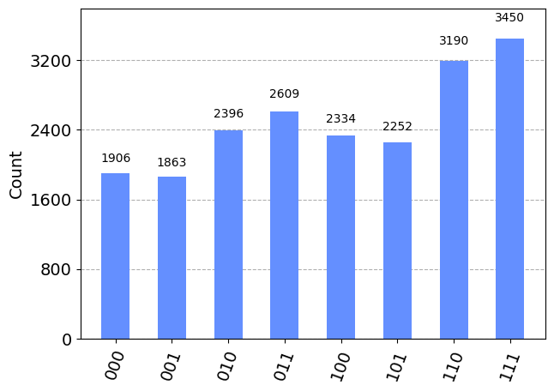

Figure 5: Histogram of QFA Quantum computer simulations.

The Histogram of the Classical results can be found in figure 6.

Figure 6: Histogram of QFA classical computer simulations.

## Quantum Fourier Transform Adders

The result of the addition 102 + 102 on a classical computer simulator produces the result 012. However, when this circuit is run on a Quantum Computer it produces various results, a histogram of the frequency of various results can be found in figure 7

Figure 7: Histogram of QFTA Quantum computer simulations.

The Histogram of the Classical results can be found in figure 8.

Figure 8: Histogram of QTFA classical computer simulations.

## Approximate Quantum Fourier Transform Adder

The Histogram of the Classical results can be found in figure 6.

Figure 9: Histogram of AQFTA classical computer simulations.

# DIscussion

## Quantum Fourier Adder

## Evidently, the histogram, figure 5, reveals significant variations in the outcomes when executed on a genuine quantum computer, as opposed to a classical computer. These disparities arise from inaccuracies in calculations, which can be primarily attributed to noise and errors inherent in quantum hardware. Furthermore, the quantum circuit's reliance on a substantial number of gates and more extensive utilization of qubits amplifies the potential for introducing errors from the quantum hardware, thereby further exacerbating the errors.

## Quantum Fourier Transformer Adder

The histogram, figure 7, clearly indicates that the precision of the circuit output is compromised when executed on a Quantum computer, as opposed to a classical computer. This is primarily attributed to hardware noise, but more prominently due to the excessive utilization of Hadamard gates. While Hadamard gates do entail qubit entanglement, such entanglement results in computation errors and noise. The greater the number of Hadamard gates employed, the more pronounced the noise in the system.

Despite the aforementioned factor, the error observed in this circuit is inferior to that of the QFA, and the number of qubits employed is also less, rendering it a more efficient option. Moreover, it exhibits a lower gate count, thereby enhancing its potential for scalability. noise.

## Approximate Quantum Fourier Transform Adder

## As a result of time limitations, the circuit was not subjected to simulation on a quantum computer, but it was anticipated that the outcomes would resemble those of the QFTA histogram. Once more, the findings are not as precise as they would be on a classical computer, owing to hardware noise and the deployment of Hadamard gates.

## Most Efficient Algorithm

Upon careful examination of the outcomes and deliberations, it can be affirmed that the QFTA exhibits superior accuracy compared to the QFA and AQFTA, as it demonstrates lesser errors and is not an approximation as the latter. Nevertheless, in terms of computational velocity, the AQFTA outperforms the QFTA due to the implementation of fewer gates, with the QFTA ranking second and the QFA being third.

However, regarding computational operations such as addition, classical computers outshine Quantum computers in terms of accuracy, owing to the minimal presence of errors in calculations.

# COnclusion

In conclusion, this report provides an overview of the modelling of Quantum Fourier Adders, Quantum Fourier Transform Adders, and Approximate Quantum Fourier Transform Adders. These adders utilize controlled-phase gates and Hadamard gates in their addition operations. The report also provides the unitary matrices for 1, 2, and 3 wire Quantum Fourier Transform circuits. This work will help in advancing the field of quantum computing and in the development of more efficient quantum adders. Further research can focus on exploring the applications of these adders and their potential to solve complex problems.